**Cytosolic detergent extraction**

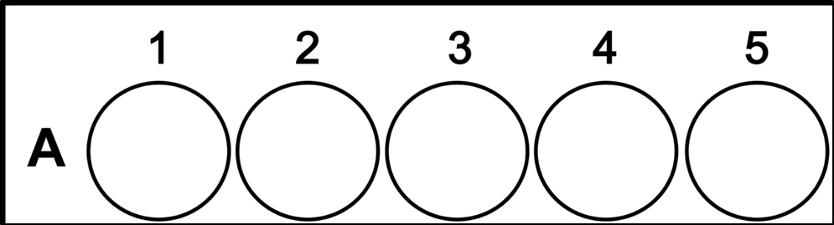

* Seed cells 24 well plate containing 12mm glass coverslips 1 day before.
* Add fresh media to cells 1 hour before the start of the experiment
* Aspirate the media and wash the cells once with 0.5 ml of 1×PBS (room temperature)
* Add 200 μl of ice-cold permeabilization buffer to the cells and incubate on ice for 5 minutes
  + Permeabilization buffer: 110 mM KOAc, 25 mM K-HEPES, pH 7.2, 2.5 mM Mg(OAc)2, 1 mM EGTA, 0.03% digitonin, 1 mM DTT, 50 mg/ml cycloheximide (CHX), 1× Complete Protease Inhibitor Cocktail, and 40 U/mL RNaseOUT™. Digitonin, DTT, CHX, Complete Protease Inhibitor Cocktail, and RNaseOUT™ must be added fresh.

|  |  |  |  |  |  |
| --- | --- | --- | --- | --- | --- |
| Wells 1🡪5 | Control  fluo | Control  Non-fluo | Permeabilization  fluo | Permeabilization  fluo | Permeabilization  RNase - fluo |
| Extraction buffer composition | / | / | Permeabilization buffer | Permeabilization buffer | Permeabilization buffer + 1 μg RNaseA |

* Wash cells gently with 0.5 ml of ice-cold wash buffer
  + Wash buffer: 110 mM KOAc, 25 mM K-HEPES at pH 7.2, 2.5 mM Mg(OAc)2, 1 mM EGTA, 0.004% digitonin, 1 mM DTT, and 50 mg/ml CHX. Digitonin, DTT and CHX must be added fresh.
* Aspirate the wash buffer and add 4% paraformaldehyde (made in 1x PBS, pH7.4) to each well. Let the cells fix for 10 minutes

**Hybridization protocol**

**Buffers to make**:

* 20X SSC (for diluting of other buffers)
* 2X SSC
* 2X SSC + 0.1%TX100
* 4X SSC
* 1.0M Tris pH8.0
* 1X PBS
* 4%paraformaldehyde in PBS, pH 7.4
* Hybridization Buffer:
  + Yeast tRNA 1mg/mL
  + BSA 0.005%
  + Dextran sulfate 10%
  + Formamide, deionized 25%
  + 20X SSC + DEPC water so that final buffer volume is in 2X SSC
* Aspirate the paraformaldehyde and add 70% ethanol to each well for at least 10 minutes. Plates can safely be stored for several days at 4 degrees in ethanol before proceeding with the hybridization step without any loss of mRNA signal or compromise in cell morphology.
* Aspirate the ethanol and add 1M Tris pH8.0 to each well for 5 minutes.
* While the cells are incubating in Tris, add the probe to the appropriate amount of hybridization buffer needed for the number of samples you have. The probe I use is a 1ug/uL stock solution. Dilute this stock 1:1000 in hybridization buffer for a final concentration of 1ng/uL.

|  |  |  |  |  |  |
| --- | --- | --- | --- | --- | --- |
| Wells 1🡪5 | Control  fluo | Control  Non-fluo | Permeabilization  fluo | Permeabilization  fluo | Permeabilization  RNase - fluo |
| Oligo concentration of Hybridization buffer | * 1ng/uL Oligo(dT)15-6FAM | * 1ng/uL Oligo(dT)15-6FAM * 10 1ng/uL Oligo(dT)15 | * 1ng/uL Oligo(dT)15-6FAM | * 1ng/uL Oligo(dT)15-6FAM   10 1ng/uL Oligo(dT)15 | * 1ng/uL Oligo(dT)15-6FAM |

* Aspirate the Tris, and add hybridization buffer with probe to each well
* Incubate at 37 degrees (incubator) for at least one hour. Keep the samples covered from here forward, so as not to bleach the fluorophore. Hybridization can continue overnight if desired.
* After hybridization, remove the plate from the bag and wash samples once with 4x SSC.
* Wash again with 2x SSC
* if you wish to stain with an antibody:
  + dilute your primary antibody in 2xSSC + 0.1% tritonX100 and incubate for 1 hr at RT (no need to block, as hyb solution contains BSA).
  + Wash three times with 2x SSC
  + incubate your secondary antibody in 2xSSC + 0.1% tritonX100 and incubate for 1 hr at RT
  + Wash twice with 2x SSC
* Mount slides